Mini Project Report On

SYNTHETIC DATA GENERATION FOR DOCUMENT TEXT RECOGNITION

Submitted in partial fulfillment of the requirements for the award of the

Bachelor of Technology

In
Department of Computer Science and Engineering

By

B. JHANSI LAKSHMI 20241A0566
B. SRIJA 20241A0564
MARIA JABEEN 20241A0593
K. KUSHI REDDY 20241A0583

Under the Esteemed guidance of

Dr. ASHLIN DEEPA R N Associate Professor



Department of Computer Science and Engineering
GOKARAJU RANGARAJU INSTITUTE OF ENGINEERING AND TECHNOLOGY
(Autonomous)

Mini Project Report On

SYNTHETIC DATA GENERATION FOR DOCUMENT TEXT RECOGNITION

Submitted in partial fulfillment of the requirements for the award of the

Bachelor of Technology

In
Department of Computer Science and Engineering

By

B. JHANSI LAKSHMI 20241A0566
B. SRIJA 20241A0564
MARIA JABEEN 20241A0593
K. KUSHI REDDY 20241A0583

Under the Esteemed guidance of

Dr. ASHLIN DEEPA R N Associate Professor

Department of Computer Science and Engineering
GOKARAJU RANGARAJU INSTITUTE OF ENGINEERING AND TECHNOLOGY
(Autonomous)

I

GOKARAJU RANGARAJU

INSTITUTE OF ENGINEERING AND TECHNOLOGY
(Autonomous)

CERTIFICATE

This is to certify that the mini project entitled “Synthetic Data Generation for Document Text Recognition” is submitted by B. Jhansi Lakshmi (20241A0566), B. Srija (20241A0564), Maria Jabeen(20241A0593), K Kushi Reddy(20241A0583) in partial fulfillment of the award of degree in BACHELOR OF TECHNOLOGY in Computer Science and Engineering during academic year 2022- 2023.

INTERNAL GUIDE HEAD OF THE DEPARTMENT
DR. ASHLIN DEEPA R N DR. K. MADHAVI
Associate Professor Professor and HOD

EXTERNAL EXAMINER

II

ACKNOWLEDGEMENT

There are many people who helped us directly and indirectly to complete our project successfully. We would like to take this opportunity to thank one and all. First we wish to express our deep gratitude towards our internal guide Dr. Ashlin Deepa R N, Associate Professor, Department of CSE for her/his support in the completion of our project report. We wish to express our honest and sincere thanks to Dr. K. Madhavi, HOD, Department of CSE and to our principal Dr. J. Praveen for providing the facilities to complete the mini project. We would like to thank all our faculty and friends for their help and constructive criticism during the project completion phase. Finally, we are very much indebted to our parents for their moral support and encouragement to achieve goals.

B. Jhansi Lakshmi (20241A0566)

B. Srija (20241A0564)
Maria Jabeen(20241A0593)
K. Kushi Reddy(20241A0583)

III

DECLARATION

We hereby declare that the mini project entitled “Synthetic Data Generation for Document Text Recognition” is the work done during the period from 12th Jan 2023 to 3rd June 2023 and is submitted in the partial fulfillment of the requirements for the award of degree of Bachelor of Technology in Computer Science and Engineering from Gokaraju Rangaraju Institute of Engineering and Technology (Autonomous under Jawaharlal Nehru Technology University, Hyderabad).The results embodied in this project have not been submitted to any other university or Institution for the award of any degree or diploma.

B. Jhansi Lakshmi (20241A0566) B. Srija (20241A0564)
Maria Jabeen(20241A0593) K Kushi Reddy(20241A0583)

IV

 | Table of Contents
Chapter | TITLE | Page No
 | Abstract
1 | Introduction | 1-2
 | 1.1ExistingSystem | 1
 | 1.1.1 Limitations in Existing System | 2
 | 1.2 Proposed System | 2
 | 1.2.1 Advantages over Existing System | 2
2 | Literature Survey | 3
3 | Software Requirement Specifications | 4-7
IEEE Standard
  - Introduction
3.1.1 Purpose of the requirements document
3.1.2 Scope of the product
3.1.3 Definitions, acronyms, and abbreviations
3.1.4 References
3.1.5 Overview of the remainder of the document
  - General description
3.2.1 Product perspective
    - Product functions
3.2.3 User characteristics
3.2.4 General constraints
3.2.5 Assumptions and dependencies
3.3 Specific requirements
 | 3.4 Feasibility Study | 6-7
 | 3.4.1 Technical Feasibility | 6
 | 3.4.2 Economic Feasibility | 7
 | 3.4.3 Operational Feasibility | 7
4 | Design | 8-11
 | 4.1 Project Description | 8
 | 4.1.1 System Use case Diagrams | 9
 | 4.1.2 Class Diagrams  V | 10

 | 4.1.3 Data Flow Diagram (DFD) | 11
5 | Implementation | 12-16
5.1 Source code (Main )
  - Screenshots (Results)
6 | Testing | 17-19
7 | Conclusion & Future Scope | 20
8 | References | 21-22

VI

List of Figures

Fig No | Fig Title | Page No
1 | Use case diagram for Synthetic data generator | 9
2 | Class diagram for Synthetic data generator | 10
3 | Data Flow diagram for Synthetic data generator | 11
4 | Importing Libraries | 12
5 | Main function | 13
6 | Writing cache memory | 14
7 | createDataset Function | 14
8 | Generating synthetic data | 15
9 | Message in terminal | 15
10 | Synthetic data generation for Kannada Language | 16
11 | Synthetic data generation for Tamil Language | 16

List of Tables

Table No | Title of the Table | Page No
1 | Test Cases | 17-19

VII

ABSTRACT

Document text recognition is an advanced technology designed to identify and extract text from scanned documents. Its primary purpose is to convert handwritten or printed text into an accessible electronic format. However, when it comes to Indian languages, the vast size of the dataset makes explicit preprocessing time-consuming. To address this challenge and streamline the process, synthetic data generation techniques have been introduced, eliminating the need for explicit preprocessing. Synthetic data refers to artificially created data that closely resembles real-world observations. It serves as a viable alternative for training machine learning models when obtaining actual data is difficult or expensive. In this project, we leverage a data preprocessing technique that involves generating synthetic data files from the existing dataset of Indian languages. These synthetic data files are structured in a way that facilitates efficient management and organization of the data, specifically tailored for document text recognition tasks. By utilizing this synthetic data, we are able to train and test language models effectively. As part of our approach, we employ the FastText model, which serves as a pre-trained language model capable of creating word embeddings. It acts as a supervisor, enabling accurate predictions using synthetic data. Through this combined methodology, we aim to enhance the accuracy and efficiency of document text recognition systems for Indian languages.

VIII

CHAPTER 1 INTRODUCTION

Document text recognition is an advanced technology that plays a crucial role in identifying and extracting text from scanned documents, including handwritten materials. In India, with its rich heritage of ancient manuscripts and historical documents written in various Indian languages, the preservation and digitization of these invaluable resources are paramount for their long-term conservation, accessibility, and scholarly research.
Handwritten Text Recognition (HTR) technology emerges as a powerful tool in facilitating the digitization, research, analysis, and preservation of these manuscripts. By digitizing handwritten texts in Indian languages, HTR contributes significantly to the preservation of regional languages and indigenous knowledge. It not only aids in capturing and documenting cultural and linguistic heritage but also ensures that this valuable information is accessible for future generations to explore and learn from. Recognizing handwritten text in Indic languages presents unique challenges, primarily due to the vast datasets involved and the complexities of preprocessing required. However, a novel approach has been introduced to streamline and expedite the preprocessing stage: synthetic data generation. Synthetic data, which emulates real-world observations, is utilized to train machine learning models when obtaining actual data is difficult or expensive. This innovative technology reduces the cost and time required for preprocessing, thus enabling more efficient and accurate recognition of handwritten text in Indic languages.
By combining the power of document text recognition, specifically HTR, with the utilization of synthetic data generation, we can unlock the potential of digitization, research, analysis, and preservation of Indian manuscripts, thereby preserving India's cultural and linguistic heritage for generations to come.

Existing System

Existing OCR systems for Indian languages have made significant progress in accurately recognizing and transcribing text from diverse scripts such as Hindi, Bengali, Tamil, and more. These systems leverage advanced techniques, including deep learning models and language-specific features, to handle the complexities of Indian scripts. They have been trained on extensive datasets, encompassing various fonts, styles, and document layouts specific to Indian languages. Notable OCR systems for Indian languages include Tesseract-Indic, OCRopus, and ABBYY FineReader with Indic language support. These systems play a crucial role in digitizing historical texts, facilitating automated data entry, and improving information retrieval in Indian languages. They vary in availability, being open-source or proprietary, but all contribute to improving OCR for Indian languages, making them more accessible and useful for a wide range of applications. Ongoing research and development efforts continue to enhance the performance and expand the capabilities of existing OCR systems, enabling more accurate and efficient recognition of Indian language content.

1

Limitations in Existing System

Although existing OCR systems work better for printed documents, there are insufficient OCR systems available for handwritten documents specifically for Indian languages. Challenges arise from the wide variation in writing styles, image quality, ink thickness, vast vocabulary, and extensive character sets in these languages. Handwriting's diverse nature and complex scripts make accurate interpretation difficult. The faint, smudged, or distorted text further complicates recognition due to poor image quality. Indian languages have large character sets with intricate combinations, posing a challenge for algorithms designed for simpler scripts.

Proposed System

Our proposed system uses specialized techniques, such as deep learning models and advanced image processing. Researchers explore data augmentation and novel approaches to improve accuracy for handwritten Indic text. Advancements in this field can unlock opportunities for digitizing historical documents, automated transcription, and information retrieval. By tailoring text recognition technology to Indian languages, we can overcome these challenges and enable efficient and accurate recognition of handwritten content. In this project, we leverage a data preprocessing technique that involves generating synthetic data files from the existing dataset of Indian languages. Through this combined methodology, we aim to enhance the accuracy and efficiency of document text recognition systems for Indian languages.

Advantages over Existing System

Existing OCR systems for Indian languages typically require extensive explicit preprocessing of datasets before they can be effectively utilized by the models. However, the large size of Indian language datasets often leads to time-consuming and costly preprocessing procedures, taking weeks to complete. In contrast, our proposed system presents a novel approach that eliminates the need for explicit preprocessing, resulting in significant reductions in both time and cost associated with the recognition process. By leveraging advanced techniques and innovative methodologies, our system streamlines the entire recognition pipeline.

2

CHAPTER 2 LITERATURE SURVEY

Although character recognition is not a new issue, its roots can be found in technologies used before the development of computers. The first OCR systems weren't computers; instead, they were mechanical machines that could recognize characters, but they did so at a very slow speed and with poor precision. Recent advancements have leveraged machine learning techniques, particularly deep learning, to improve Indian OCR. Convolutional Neural Networks (CNNs) and Recurrent Neural Networks (RNNs) have been employed for character recognition, yielding promising results in various Indian scripts.

Several attempts to recognize handwritten text in various languages have been attempted in recent years. For offline Handwritten Text recognition, Chandra Prakash Konkimalla utilized a deep learning-based OCR algorithm[1]. Minghao Li 1 proposed an end-to-end text recognition approach with a pre-trained image Transformer[2]. Z. Zhong used a unified framework for text detection in natural images[5]. Zhang, X., Tan, C proposed a new segmentation-free method for keyword spotting in handwritten documents based on Heat Kernel Signature[7].Rostom Kachouri and Christian Medina developed Kannada letter handwritten recognition using a deep convolutional neural network on Android platform[12]. Bhattacharya utilised a algorithm for Devanagari and Bangla Text Extraction from Natural Scene Images[13]. Denis Coquenet, Clément Chatelain proposed a Faster DAN, a two-step strategy to speed up the recognition process[14].

Multiple OCR systems have been developed specifically for Indian languages. These systems cater to different scripts and provide accurate recognition capabilities through a combination of rule-based and machine-learning approaches. Despite significant progress, Indian OCR still faces challenges such as ligature recognition, handling cursive scripts, and variations in writing styles. Future research should focus on addressing these challenges, expanding dataset coverage, and exploring novel techniques such as transfer learning and domain adaptation. The availability of language-specific OCR systems and datasets has played a crucial role in improving recognition accuracy for Indian languages.

However, further research is needed to overcome the challenges posed by complex scripts and variations in handwriting styles. Continued efforts in Indian OCR will pave the way for efficient digitization, information retrieval, and language preservation of Indian language texts.

3

CHAPTER 3
SOFTWARE REQUIREMENT SPECIFICATIONS

Introduction:

    - Purpose of the requirements document:

The purpose of synthetic data refers to the use and generation of artificially created data for training and evaluating OCR models. The general idea is to recognize and extract text from documents written in multiple languages, specifically Indian. It involves creating synthetic data to accurately recognize the unique characteristics and variations of handwritten text, which is generally more challenging than printed text recognition. It can be used for evaluating and benchmarking the performance of OCR models.

Scope of the Product:

The scope of this project is to develop software that specializes in synthesizing a diverse and comprehensive dataset of Indian languages. The primary objective is to provide researchers and developers with a high-quality synthesized dataset, encompassing various Indian languages, to facilitate and accelerate the process of model building and language-related research. Overall, the scope is to enable the efficient and accurate conversion of text from non-editable sources into machine-readable and searchable formats.

Definitions, acronyms, and Abbreviations:
HTR: Handwritten Text Recognition
      - It is a technology that aims to automatically recognize and transcribe handwritten text from images into machine-readable and editable text.
OCR: Optical Character Recognition
      - It is a technology that converts printed or handwritten text from images or scanned documents into machine-readable and editable text.

    - References:
Ajoy Mondal and C. V. Jawahar, “Enhancing Indic Handwritten Text Recognition using Global Semantic Information”, 15 Dec 2022..

3.1.5 Overview of the remainder of the document:

The report's remaining sections are organized as follows:
Chapter 4: Design of the project

Chapter 5: Implementation of code Chapter 6: Testing
Chapter 7: Conclusion and Further Scope

4

Chapter 8: References

Chapter 9:List of Figures and Tables

General Description:

    - Product Perspective:

Our synthetic dataset has an augmented version of the original dataset that can be helpful for recognizing Handwritten Indian languages. The product perspective focuses on accurately representing the characteristics, variations, and complexities of Indian languages in the synthetic data. This includes capturing the nuances of different scripts, fonts, writing styles, ligatures, diacritics, and other language-specific features to ensure the synthetic data closely resembles real-world text. The product perspective considers the scalability and efficiency of synthetic data generation.

Product Function:

The product function focuses on generating synthetic data that closely resembles real-world text scenarios. This involves defining methods and techniques to efficiently create large-scale synthetic datasets that can handle the training requirements of the OCR system. The product function addresses the use of synthetic data for training and evaluating the OCR system. This includes defining the training process, data augmentation techniques, and evaluation methodologies to ensure that the OCR model trained on synthetic data achieves the desired performance objectives.

User Characteristics:

The use of synthetic data generated for training OCR systems offers several advantages for researchers and developers. Instead of relying solely on traditional datasets, incorporating synthetic data can provide additional flexibility and diversity in the training process. With synthetic data, researchers have greater control over the data generation process. They can manipulate specific characteristics, introduce controlled variations, and systematically evaluate the OCR system's performance under different conditions. This controlled experimentation allows researchers to assess the system's strengths, weaknesses, and areas for improvement, leading to more targeted and effective algorithm development.

General Constraints:

FastText operates on the word level and does not capture the contextual nuances of sentences or documents. It represents words as a continuous bag of n-grams, which can limit its ability to understand the semantic relationships and meaning within a sentence. This limitation may lead to the generation of synthetic data that lacks the complexity and subtlety of real-world text. Since FastText generates text based on statistical patterns observed in the training data, it may produce synthetic data that lacks coherence and structural integrity. Synthetic data generated by FastText is trained on a large corpus of text from various sources, which makes it more suitable for general-purpose text generation. However, when it comes to domain-specific tasks, such as technical or scientific text, the FastText model may struggle to generate accurate and specialized content.

5

Assumptions and Dependencies:

The FastText model assumes that the order of words in a text does not carry significant meaning. It treats each text as a bag of words, disregarding the sequential structure of sentences or documents. This assumption allows the model to efficiently process and represent text using word embeddings. The FastText model relies on the distributional hypothesis, which suggests that words occurring in similar contexts tend to have similar meanings. The performance of the synthetic data generated by the FastText model depends on the representativeness and quality of the training data. It assumes that the training data is diverse, well-labeled, and covers a wide range of word usage and contexts. Biased or unrepresentative training data can lead to suboptimal results and reduced generalization capability.

Specific requirements:

FastText can be run on a standard computer with sufficient processing power and memory. The specific hardware requirements depend on the size of the dataset and the complexity of the model. The synthetic data should accurately represent the linguistic characteristics, writing styles, and typographic variations of each
script. The data should represent a diverse set of text samples, including different types of documents, texts from different sources, and variations commonly encountered in practical OCR applications. The synthetic data should allow for the generation of text placed on various types of backgrounds. It should support plain backgrounds, textured backgrounds, and backgrounds with varying complexities. By fulfilling these specific requirements, the creation of synthetic data for OCR ensures that the generated datasets effectively represent real-world text scenarios and contribute to the training and evaluation of accurate and robust OCR models.

Feasibility Study:

    - Technical Feasibility:

The main technologies and tools that are required for the project are:
      - Anaconda (3.7.0)
      - FastText model (Each separate model for each language)
      - MDB Viewer
      - Text Editor - Visual Studio Code
      - Programming device (Laptop)
The Anaconda distribution serves as a robust platform for coding in Visual Studio Code, primarily focusing on Python development. To augment our language-related tasks, we leverage diverse FastText models
specifically tailored for different languages. Developed by Facebook AI Research, FastText is a highly
efficient library that enables text classification and representation learning. To gain valuable insights into the synthetic data we generate, we rely on the MDB Viewer.

6

Economic Feasibility:

Each of the technologies used, including Anaconda, FastText, and MDB Viewer, is freely available, making them easily accessible to users. This eliminates any financial barriers and ensures that individuals can leverage the power of these tools without incurring additional costs. Moreover, the technical skills required to utilize these technologies are manageable for users. While obtaining a raw dataset for a project may not necessarily be costly in monetary terms, it does demand a significant investment of time. Gathering a
comprehensive and relevant dataset involves various steps, such as data collection, cleaning, preprocessing, and annotation, which can be time-consuming and labor-intensive.

Operational Feasibility:

The program performs well with small datasets of Indian languages, but its ability to handle large datasets is uncertain due to limited data availability. Large datasets are essential for accurate model training and validation. Without sufficient data, the program's performance on extensive datasets cannot be guaranteed, potentially leading to overfitting. To address this limitation, efforts should be made to obtain or create larger datasets through collaboration, data sharing, or synthetic data generation. Expanding the dataset would
enhance the program's capabilities and ensure reliable performance when dealing with larger and more diverse Indian language datasets.

7

CHAPTER 4 DESIGN

Project Description:

The project focuses on generating synthetic data for various Indian languages which can be used for training the language models for document text recognition and OCR. The synthetic data is generated by using a FastText model. The project consists of three main modules namely Rectification Module, encoder module, and semantic module. The following algorithm is used in the project:

Rectification Module:
•The Rectification module rectifies the given input text image.
•Using Spatial Transformation Network (STN), rectification is done in order to simplify text recognition.
The Spatial Transformer Network (STN) is a deep learning technique that can be used to improve the performance of tasks such as text recognition by explicitly applying spatial transformations to the input data. It allows the neural network to learn to selectively focus on relevant regions of the input, making it more robust to variations in scale, rotation, and translation.

Encoder module

•Image from the rectified module is forwarded to the encoder module (ResNet-based CNN followed by 2-layer Bidirectional LSTM (BiLSTM)).
•Encoder module gives a feature sequence as the output.
A 2-layer Bidirectional LSTM (Long Short-Term Memory) is a type of recurrent neural network (RNN) architecture commonly used in document text recognition tasks. It is designed to capture the sequential dependencies in the input document and provide a robust representation for accurate recognition.

Semantic module
•The semantic module uses feature sequences for accurately predicting characters.
•Word embedding from pre-trained language model
•(FastText) acts as a supervisor to predict semantic information.
•Embedding vectors of all subwords combined to represent corresponding words.
The FastText module is a powerful and efficient library developed by Facebook AI Research for text classification and representation learning tasks. It provides a range of functions and capabilities that enable users to effectively work with textual data, including language identification, text categorization, and word vector representations.

8

System Use Case Diagrams:
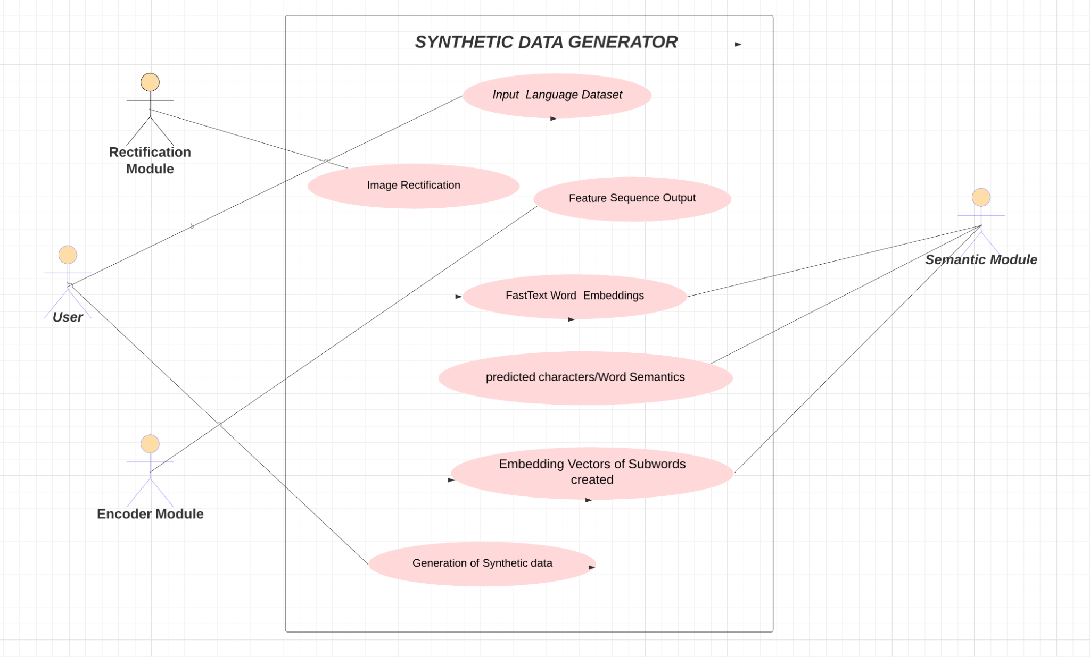

Fig. 1 Use case diagram for Synthetic data generator

A Use Case diagram illustrates the interaction between actors and the system.

Actors:

Users,Rectification Module,Encoder module,Semantic module.

Use Cases:

Input Language dataset- The dataset consisting of word images of a language is given as input by the user.

Rectification- It involves applying transformations or adjustments to ensure that the word images are properly aligned, oriented, or scaled for further processing.

Spatial Transformation Network (STN)- It involves applying transformations or adjustments to ensure that the word images are properly aligned, oriented, or scaled for further processing.

Feature Sequence Output- The Feature Sequence Output represents the intermediate output obtained from the STN or other processing steps.

FastText Word Embeddings- FastText Word Embeddings are vector representations of words generated using the FastText algorithm.
9

Predicted Characters/Word Semantics- Predicted Characters/Word Semantics refer to the output obtained from the model or system based on the processed features or word embeddings.

Embedding Vectors of Subwords Combined- Embedding Vectors of Subwords Combined refers to the process of combining embedding vectors of subwords to represent words.

Generation of Synthetic data- It involves utilizing the processed features, embeddings, or predicted characters/word semantics to generate synthetic data that resembles the original language dataset.

Class diagram:

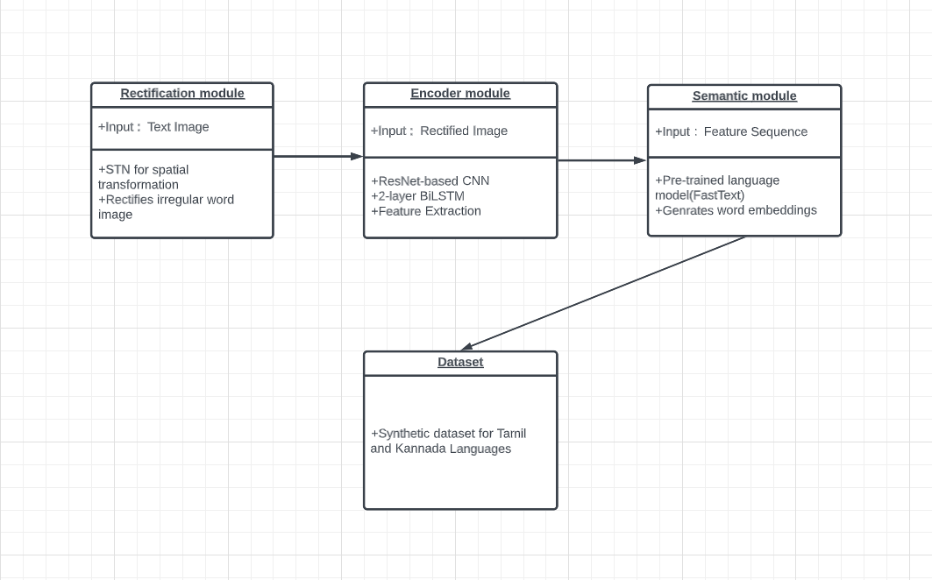

Fig. 2 Class diagram for Synthetic data generator

A class diagram illustrates the relationships of classes within a system.

The class diagram represents the system's structure, focusing on three essential modules: Rectification, Encoder, Semantic. These three modules combined give the dataset module where synthetic dataset is generated. The Rectification module rectifies input text images using the Spatial Transformation Network (STN). The Encoder module extracts feature sequences using a combination of ResNet-based CNN and
Bidirectional LSTM (BiLSTM). The Semantic module predicts characters by utilizing the feature sequences and a pre-trained language model like FastText for semantic information. Dataset module encompasses the synthetic data used for training and evaluation, generated through rectification, feature extraction, and word embedding.

10

Data Flow Diagram:

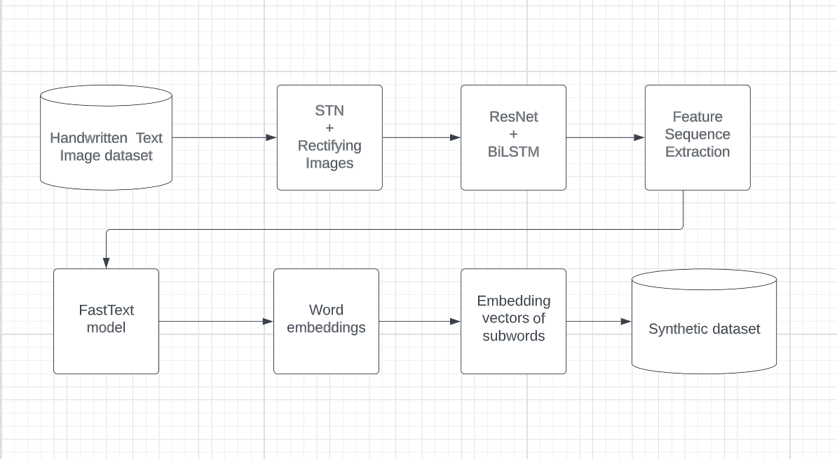

Fig. 3 Data Flow diagram for Synthetic data generator

A data flow diagram is a diagram that illustrates the flow within the system or a process. Fig 3 shows us the data flow of generation of synthetic dataset from the original dataset.
The handwritten text image dataset acts as a valuable source of real-world examples and serves as the foundation for creating synthetic data.
The process of synthetic data generation involves rectification using STN to simplify the text, feature sequence extraction using ResNet-based CNN and BiLSTM to capture relevant information, and the creation of word embeddings using FastText to add semantic information. These steps work together to produce synthetic data that closely resembles real-world handwritten text, improving the performance and effectiveness of the subsequent tasks, such as training and evaluating handwritten text recognition models.

11

CHAPTER 5
Implementation

5.1. Source code (Main):

Input:

We utilized a comprehensive Tamil dataset for our project, incorporating an extensive range of images. The train dataset is composed of 75,737 images, while the test dataset encompasses 16,185 images. Additionally, our validation dataset consists of 11,599 images.

Similarly, we used a Kannada dataset for our project, containing several images. The train dataset has 73,499 images, while the test dataset is composed of 9999 images. Additionally, our validation dataset consists of 13,784 images.

Code:

Importing the required libraries and FastText model.

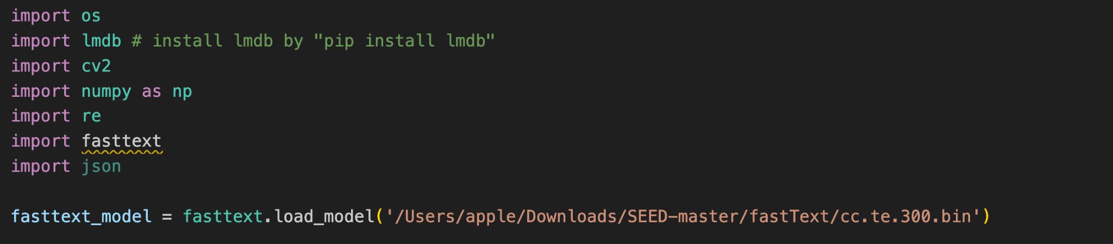

Fig. 4 Importing Libraries

12

In this the paths to the language dataset are given, the dataset consists of a folder consisting of images(test in this case) and another folder (test.txt in this case) consisting of the name of the images. The text file is used to retrieve the images by mapping the names to images.
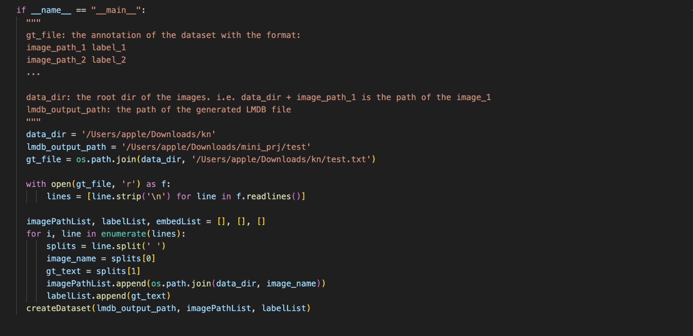

Fig. 5 Main function

13

This part of the code writes cache memory to create mdb files and write synthesized data into it.
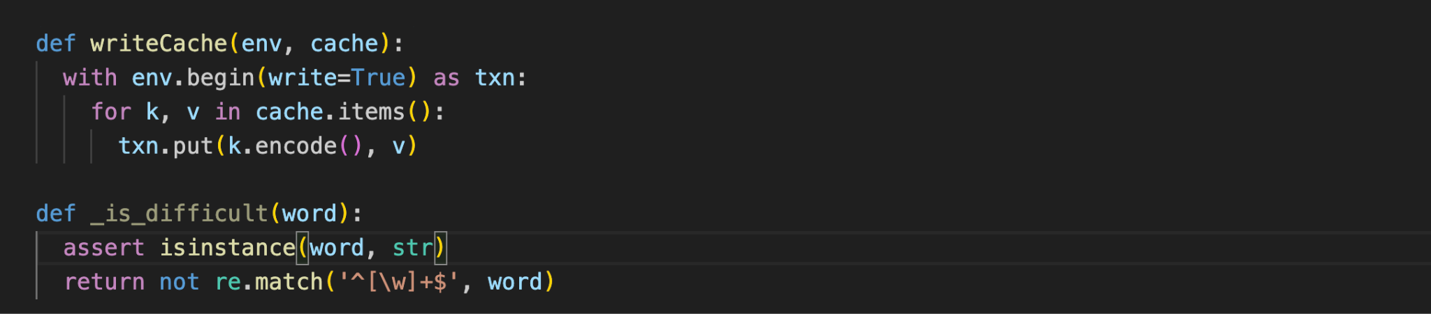

Fig. 6 Writing cache memory

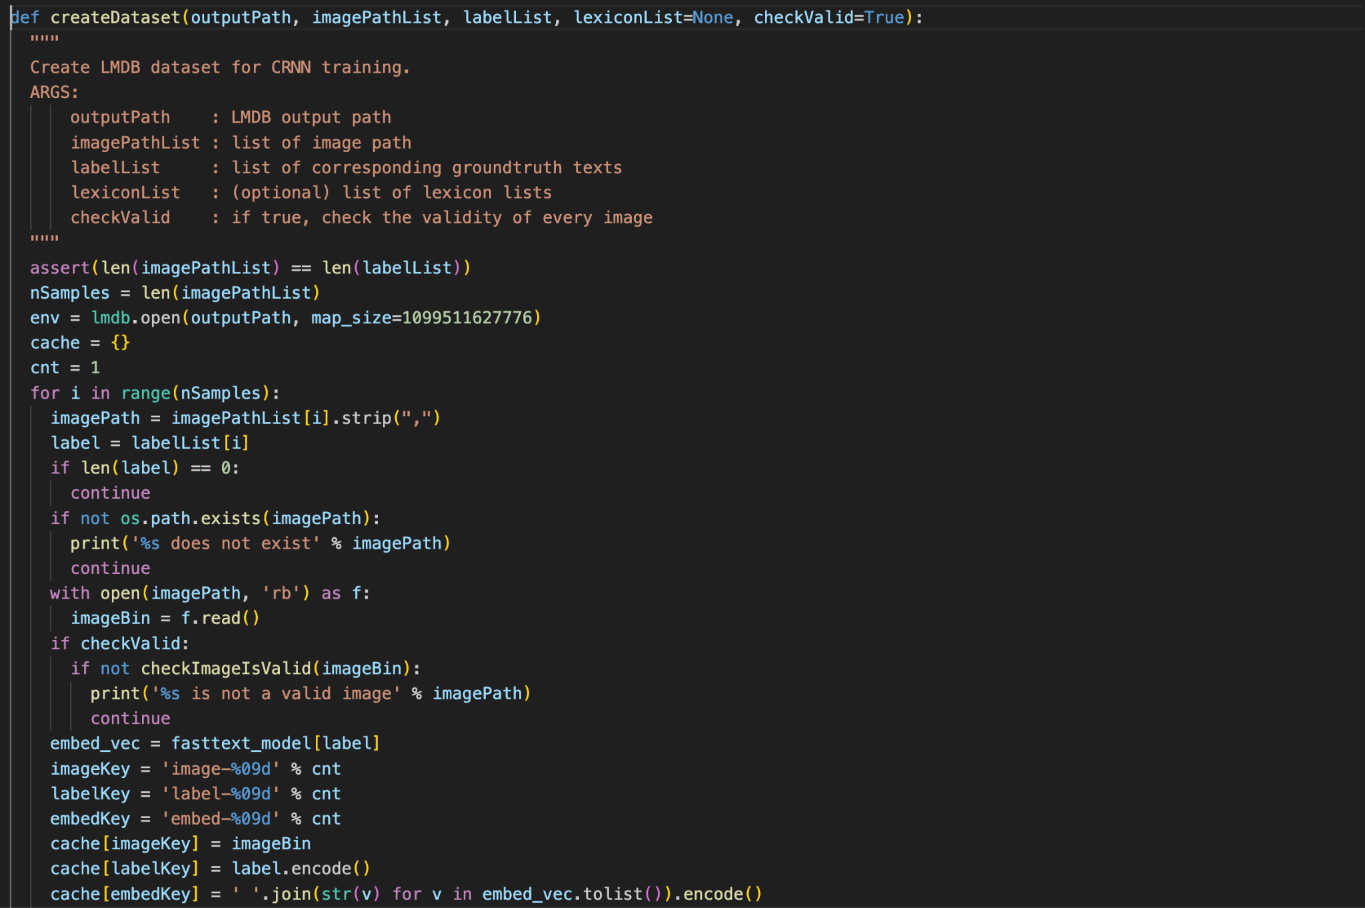
Here in the createDataset function, the function first checks whether the data exist or not at the given path. If it exists, it writes cache, otherwise it informs the programmer that the data does not exist.

Fig. 7 createDataset Function

14

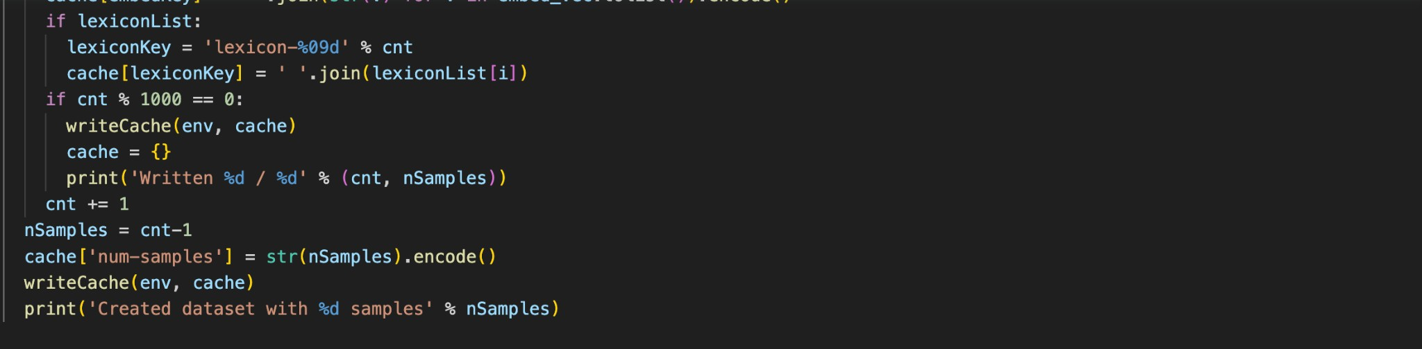
This is the end part of the code where the synthetic dataset is created.
Fig. 8 Generating synthetic data

5.2 Screenshots (Results):

Output:

Message displaying the generation of synthetic data:
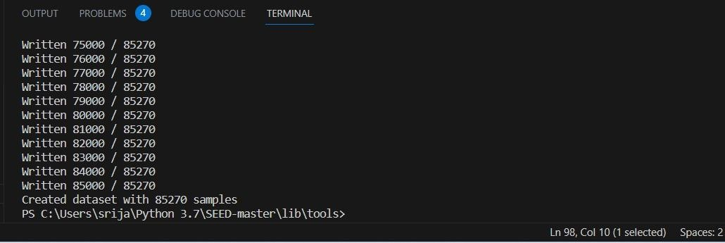

Fig.9 Message in terminal

15

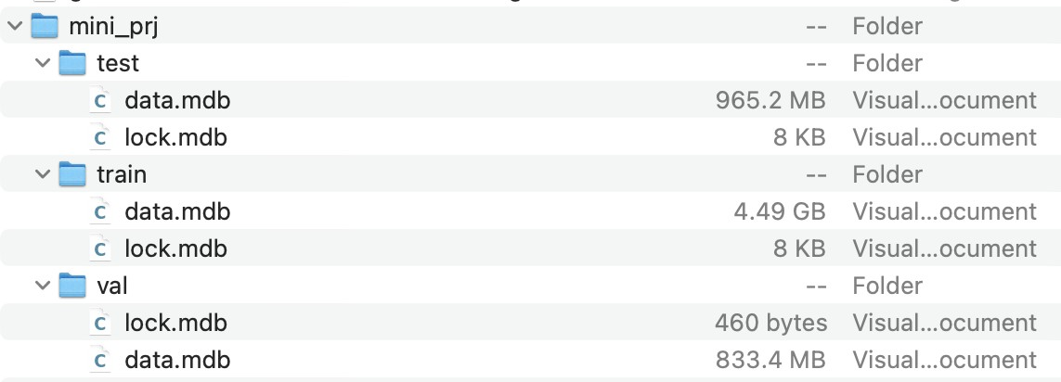
Synthetic data generation for Kannada language:

Fig. 10 Synthetic data for Kannada Language

Synthetic data generation for Tamil Language:
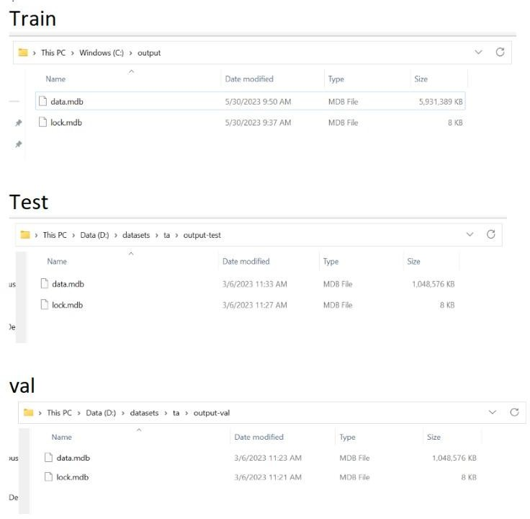
Fig. 11 Synthetic data generation for Tamil Language

16

CHAPTER 6 TESTING
Test Cases:
17
Test Cas e ID | Test Scenar ios | Test Case | Precondition s | Test steps | Test Data | Expecte d results | postconditions | Actual Results | Sta tus Pass  /Fail
1 | Train | Tamil | Downloadin g the  FastText model and required dataset. | Add the path to the  FastText model, the dataset file, and the destination  folder to store the data generated. | Tamil Training dataset | To generate mdb files | Files are generated in the destination folder. | mdb files generated | Pass
2 | Test | Tamil | Downloadin g the  FastText model and required dataset. | Add the path to the  FastText model, the dataset file, and the destination  folder to store the data generated. | Tamil test dataset | To generate mdb files | Files are generated in the destination folder. | mdb files generated | Pass
3 | Validat ion | Tamil | Downloadin g the  FastText model and required dataset. | Add the path to the  FastText model, the dataset file, and the destination  folder to store the data generated. | Tamil validatio n dataset | To generate mdb files | Files are generated in the destination folder | mdb files generated | Pass
4 | Trainin g on | Tamil | Downloadin g the | Add the path to the | Tamil unique | To generate | Files are generated in | mdb files generated | Pass

 | unique dataset |  | FastText model and required dataset. | FastText model, the dataset file, and the destination  folder to store the data generated. | dataset | mdb files | the destination folder
5 | Train | Kann ada | Downloadin g the  FastText model and required dataset. | Add the path to the  FastText model, the dataset file, and the destination  folder to store the data generated. | Kannada train dataset | To generate mdb files | Files are generated in the destination folder | mdb files generated | Pass
6 | Test | Kann ada | Downloadin g the  FastText model and required dataset. | Add the path to the  FastText model, the dataset file, and the destination  folder to store the data generated. | Kannada test dataset | To generate mdb files | Files are generated in the destination folder | mdb files generated | Pass
7 | Validat ion | Kann ada | Downloadin g the  FastText model and required dataset. | Add the path to the  FastText model, the dataset file, and the destination  folder to store the data generated.. | Kannada validatio n dataset | To generate mdb files | Files are generated in the destination folder | mdb files generated | Pass
8 | Train | Telug u | Downloadin g the  FastText model and required dataset. | Add the path to the  FastText model, the dataset file, and the destination  folder to store the data generated.  18 | Telugu train dataset | To generate mdb files | Files are generated in the destination folder | mdb files generated | Pass

9 | Test | Telug u | Downloadin g the  FastText model and required dataset. | Add the path to the  FastText model, the dataset file, and the destination  folder to store the data generated. | Telugu test dataset | To generate mdb files | Files are generated in the destination folder | mdb files generated | Pass
10 | Validat ion | Telug u | Downloadin g the  FastText model and required dataset. | Add the path to the  FastText model, the dataset file, and the destination  folder to store the data generated.  19 | Telugu validatio n dataset | To generate mdb files | Files are generated in the destination folder | mdb files generated | Pass

CHAPTER 7

CONCLUSION AND FURTHER SCOPE

The synthetic data can be generated for any language using a pre-trained language model. In the future, this predicted global semantic information, which serves as synthetic data, can be utilized to initialize the decoder. By utilizing the predicted global semantic information as a form of synthetic data, the decoder can be primed to handle challenging scenarios more effectively. In cases where word images contain incomplete or blurred characters, the decoder's initialization with this semantic information provides a valuable head start, enabling it to make accurate predictions and overcome ambiguity. This approach also helps address the issue of noise or interference present in the images, as the semantic information acts as a robust and reliable guide for the decoding process. Overall, the integration of synthetic data and global semantic information into the decoding framework represents a promising avenue for advancing the ﬁeld of computer vision and natural language understanding. With continued research and development, this approach has the potential to signiﬁcantly improve the accuracy and robustness of text recognition systems, beneﬁting a wide range of applications and industries.

20

CHAPTER 8

REFERENCES(PAPERS, WEBSITES, TEXTBOOK)

- Konkimalla Chandra Prakash, Y. M. Srikar, Gayam Trishal, Souraj Mandal, Sumohana S.
Channappayya, “OPTICAL CHARACTER RECOGNITION (OCR) FOR TELUGU” 25 Dec 2018.

- Minghao Li1, Tengchao Lv2, Jingye Chen2, Lei Cui2, Yijuan Lu2, Dinei Florencio2, Cha Zhang2, Zhoujun Li1, Furu Wei2, “Transformer-based Optical Character Recognition with Pre-trained Models” 6 Sep 2022.

- Rowel Atienza, “ Vision Transformer for Fast and Efficient Scene Text Recognition” 18 May 2021.
- M. Geetha, R C Pooja, J. Swetha, N. Nivedha, T. Daniya, “Implementation of Text Recognition and Text Extraction on Formatted Bills using Deep Learning”

- Z. Zhong, L. Jin, S. Zhang, and Z. Feng. Deeptext: A unified framework for text proposal generation and text detection in natural images. arXiv preprint arXiv:1605.07314,2016.

- Y. Zhu, C. Yao, and X. Bai. Scene text detection and recognition: Recent advances and future trends. Frontiers of Computer Science,2016.

- Zhang, X., Tan, C.: Segmentation-free keyword spotting for handwritten documents based on heat kernel signature. In: Document Analysis and Recognition (ICDAR), 2013 12th International Conference on. (2013)

- Smith., Ray: An overview of the Nanonet OCR engine, the Ninth International Conference on Document Analysis and Recognition, ICDAR 2007, vol. 2, pp. 629–633, IEEE,2007.

- YibinYe, ShenggaoZhu, JingWang, QiDu, YezhangYang, DandanTu, Lanjun Wang and JieboLuo, YibinYe, Senggao Zhu, Jing Wang, Qi Du, Yezhang Yang, iDandanTu, Lanjun Wan and JieboLuo-A unified scheme of text localization and structured data extraction for joint OCR and data mining.

- Real-time text extraction from complex colored images rostom kachouri, christian medina, armas, AND Mohamed Akil.

- Strouthopoulos, N. Papamarkos, and A.E. Atsalakis, “Text extraction in complex color documents,” Pattern Recognition, vol. 35, pp. 1743–1758, August 2002

21

- RostomKachouri, Christian Medina Armas and Mohamed AkilUniversite Paris-Est, Laboratoired’informatique Gaspard-Monge, A3SI, ESIEE Paris, CNRS, Franc [9] S.Purnamawati, D.
Rachmawati, Lumanauw, R.F. Rahmat, R. Taqyuddin, “Kannada letter handwritten recognition using deep convolutional neural network on android platform,” J. of Physics: Conf. Series, 2018.

- Bhattacharya, U., Parui, S. K., &Mondal, S. (2009). Devanagari and Bangla Text Extraction from Natural Scene Images. 2009 10th International Conference on Document Analysis and Recognition.

- Denis Coquenet, Clément Chatelain, Thierry Paquet, “Faster DAN: Multi-target Queries with Document Positional Encoding for End-to-end Handwritten Document Recognition” 25 Jan 2022.

- J.Saketha Nath and Parag Chaudhuri, “OCR for Printed Telugu Documents” Indian Institute of Technology Bombay Mumbai, 21 June 2012.

Base Paper - https://arxiv.org/pdf/2212.07776v1.pdf

22
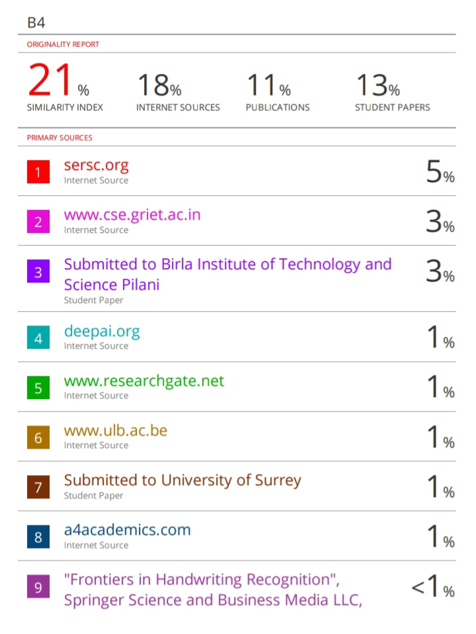
23
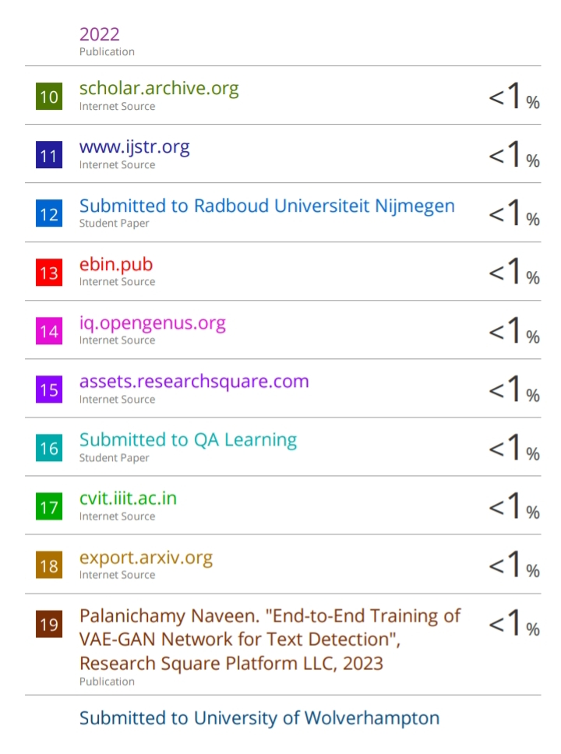
24
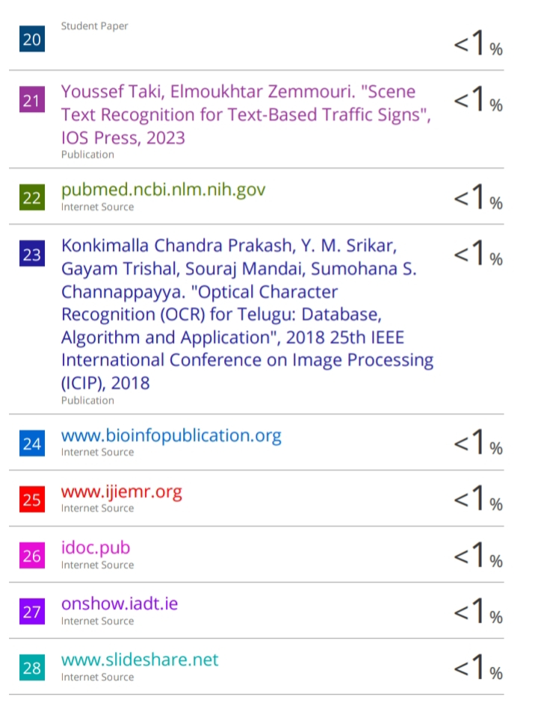
25

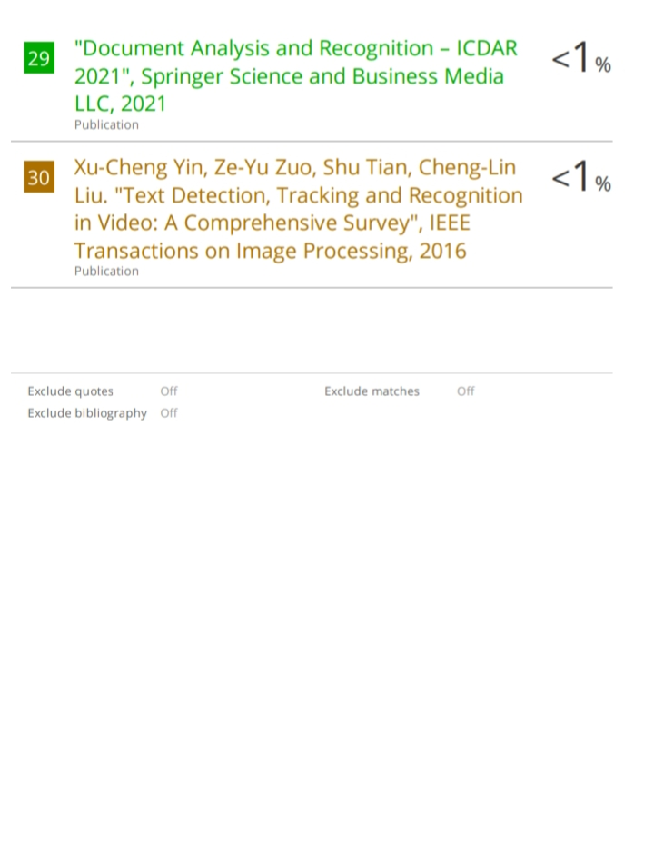

26

